**System requirements**

**System Requirements**

To completely use the **Ledget** Accounting Software client computer must have these minimum requirements.

**Minimum System Requirements**

* Windows 7/10 Version
* 2 GB RAM

**Third Party Software Requirements**

* MySQL 5
* Net Framework 4.6.1

**Server Requirements**

* Windows 7/10 Version - *Preferably Windows Server 2008 or later*
* 2 GB RAM
* 500 GB Storage

**Installation**

**Ledget System Installation**

Client and server program installation and initial setup

Program installation setup can be found on the software bundle, the **Ledget Server Setup** and **Ledget Setup**

**Bundle Files**



**Client Installation**

On the software bundle, open the "Ledget Setup" installer to install the client program and just follow the installation steps.

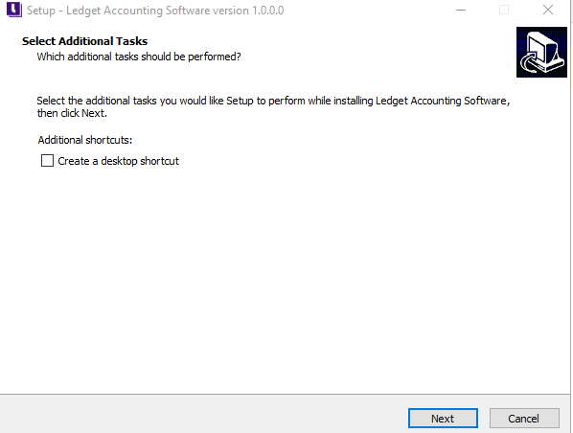

**Server Installation**

On the software bundle, open the "Ledget Server Setup" installer to install the client program and just follow the installation steps.

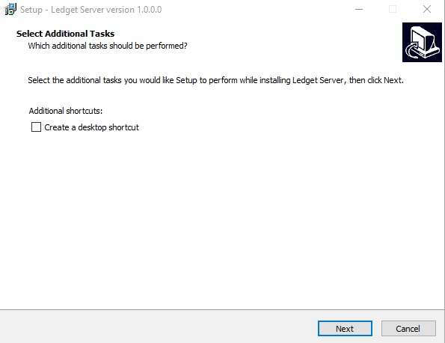

**Initial Setup**

**Ledget Initial Setup**

After installation, the system must be setup first on client and server side.

**Server Setup**

Open the "Ledget Server" program that can be found on the installed programs startup menu.

Ledget Server Program



The program will ask for database authentication, username and password. Default username is root and password is empty but if you setup the accounts differently in MySQL during installation then use that account on the "Ledget Server Setup" and just follow the setup steps until the program will promt for "successfully setup" message.

Asking for database authentication



Successful Setup

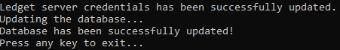

**Client Setup**

If the client computer is not the server then the program will produce an error after opening says unable to connect to any database host, just **Ignore** the error to open the program. When the program is already opened, click the "Click Here" button from the bottom right corner of the login screen.

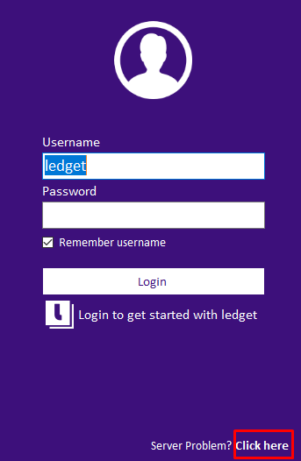

Specify the server address which where the server setup then click "Save Server Connection" then the program will restart to apply the changes.

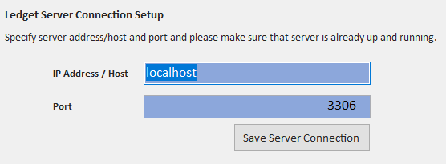

**Application Default Account**

This is the default administrator account on the system, once logged in, go to account management and change the default password to secure the system.

**Username**: ledget

**Password**: password